**Exercise 1: Control Structures**

**SCENARIO 1: Write a PL/SQL block that loops through all customers, checks their age, and if they are above 60, apply a 1% discount to their current loan interest rates.**

BEGIN

  FOR cust_rec IN (

    SELECT customer_id, loan_interest_rate, age

    FROM customers

    WHERE age > 60

  ) LOOP

    UPDATE customers

    SET loan_interest_rate = loan_interest_rate - 1

    WHERE customer_id = cust_rec.customer_id;

    DBMS_OUTPUT.PUT_LINE('Discount applied for Customer ID: ' || cust_rec.customer_id);

  END LOOP;

  COMMIT;

END;

**SCENARIO 2: Write a PL/SQL block that iterates through all customers and sets a flag IsVIP to TRUE for those with a balance over $10,000.**

BEGIN

  FOR cust_rec IN (

    SELECT customer_id, balance

    FROM customers

    WHERE balance > 10000

  ) LOOP

    UPDATE customers

    SET isvip = 'TRUE'

    WHERE customer_id = cust_rec.customer_id;

    DBMS_OUTPUT.PUT_LINE('VIP status granted to Customer ID: ' || cust_rec.customer_id);

  END LOOP;

  COMMIT;

END;

**SCENARIO 3: Write a PL/SQL block that fetches all loans due in the next 30 days and prints a reminder message for each customer.**

BEGIN

  FOR loan_rec IN (

    SELECT l.loan_id, c.customer_name, l.due_date

    FROM loans l

    JOIN customers c ON l.customer_id = c.customer_id

    WHERE l.due_date <= SYSDATE + 30

  ) LOOP

    DBMS_OUTPUT.PUT_LINE(

      'Reminder: Loan ID ' || loan_rec.loan_id ||

      ' for customer ' || loan_rec.customer_name ||

      ' is due on ' || TO_CHAR(loan_rec.due_date, 'DD-MON-YYYY')

    );

  END LOOP;

END;

**OUTPUT**:

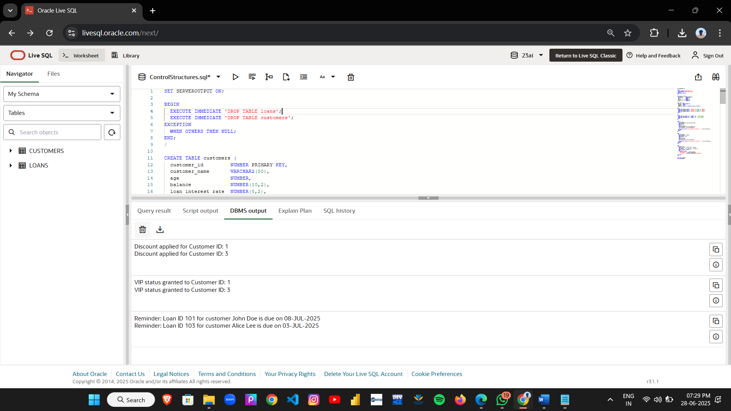

**Exercise 3: Stored Procedures**

**Scenario 1:Write a stored procedure ProcessMonthlyInterest that calculates and updates the balance of all savings accounts by applying an interest rate of 1% to the current balance.**

CREATE OR REPLACE PROCEDURE ProcessMonthlyInterest IS

BEGIN

UPDATE accounts

SET balance = balance + (balance * 0.01)

WHERE UPPER(account_type) = 'SAVINGS';

DBMS_OUTPUT.PUT_LINE('Interest applied to all savings accounts.');

COMMIT;

END;

**Scenario 2:Write a stored procedure UpdateEmployeeBonus that updates the salary of employees in a given department by adding a bonus percentage passed as a parameter.**

CREATE OR REPLACE PROCEDURE UpdateEmployeeBonus (

p_dept IN VARCHAR2,

p_bonus_pct IN NUMBER

) IS

BEGIN

UPDATE employees

SET salary = salary + (salary * p_bonus_pct / 100)

WHERE LOWER(department) = LOWER(p_dept);

DBMS_OUTPUT.PUT_LINE('Bonus of ' || p_bonus_pct || '% applied to ' || p_dept || ' department.');

COMMIT;

END;

**Scenario 3:Write a stored procedure TransferFunds that transfers a specified amount from one account to another, checking that the source account has sufficient balance before making the transfer**

CREATE OR REPLACE PROCEDURE TransferFunds (

p_from_account IN NUMBER,

p_to_account IN NUMBER,

p_amount IN NUMBER

) IS

v_balance NUMBER;

BEGIN

SELECT balance INTO v_balance

FROM accounts

WHERE account_id = p_from_account;

IF v_balance < p_amount THEN

RAISE_APPLICATION_ERROR(-20001, 'Not enough balance in source account.');

END IF;

UPDATE accounts

SET balance = balance - p_amount

WHERE account_id = p_from_account;

UPDATE accounts

SET balance = balance + p_amount

WHERE account_id = p_to_account;

DBMS_OUTPUT.PUT_LINE(p_amount || ' transferred from Account ' || p_from_account || ' to Account ' || p_to_account);

COMMIT;

END;

**Execution of all procedures:**

BEGIN

DBMS_OUTPUT.PUT_LINE('ProcessMonthlyInterest:');

ProcessMonthlyInterest;

DBMS_OUTPUT.PUT_LINE('');

DBMS_OUTPUT.PUT_LINE('UpdateEmployeeBonus (Sales, 10%):');

UpdateEmployeeBonus('Sales', 10);

DBMS_OUTPUT.PUT_LINE('');

DBMS_OUTPUT.PUT_LINE('TransferFunds (103 -> 102, amount 2000):');

TransferFunds(103, 102, 2000);

DBMS_OUTPUT.PUT_LINE('');

END;

**Output:**

